AE 302 MATLAB QUIZ 2. DUE March 22, 2024

The Black Brant V rocket motor produces an average thrust level of 15,596 pounds and an action time of 32.42 seconds. The primary diameter of the Black Brant V is 17.26 inches and it is 210 inches long. Loaded weight of the motor including hardware is 2,803 pounds which includes 2243 pounds of propellant.

https://sites.wff.nasa.gov/code810/vehicles/Black_Brant_V.pdf

Assuming a payload of 1000 pounds, a drag coefficient of 0.75, and a launch angle with respect to the horizontal of 60 degrees, how far away will the rocket be when it hits the ground?

You can neglect changes in thrust with changing atmospheric pressure and the curvature of the earth, but need to account for changes in atmospheric density with elevation. You may need to account for changes in the value of g if the rocket goes high enough.

Write the MATLAB code to solve this problem. Define all the necessary initial condition values to solve this problem.

To complete this objective a valid solution technique must be used and final answer must be within +/- 1% of the correct answer.

You may discuss this problem with your classmates, but each person must write and submit their own MATLAB code. Codes will be compared using the Turnitin software.

Answer:

- Range = 343.39 km

PASTE MATLAB CODE AS TEXT BELOW:

include a plot of your 2D trajectory:

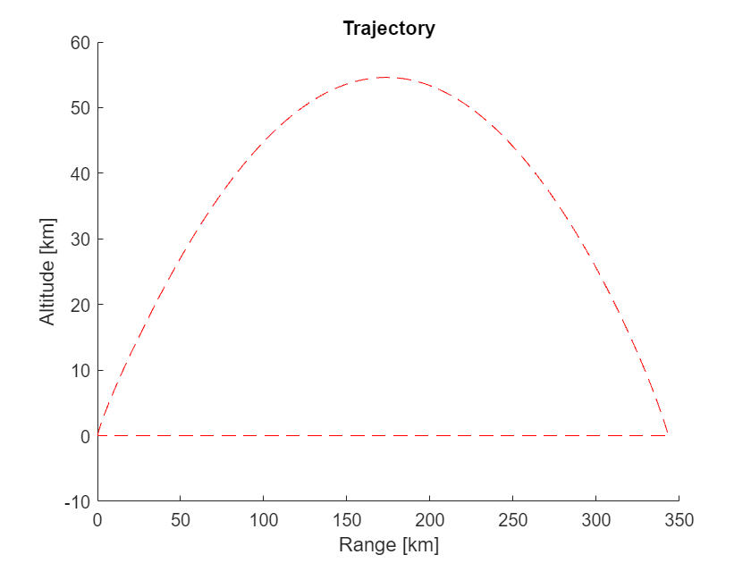
clc
clf
close all
clear

%aeroDataPackage is the atmospheric and gravitational data toolbox used

ActionTime = 32.42; %seconds
D_vehicle = 17.26*2.54/100; %m
L_vehicle = convlength(210, 'in', 'm'); %m
M_fuel = (2243)/2.205; %kg
M_total_val = (560 + 2243 + 1000)/2.205; %kg
R = 6378.100*1000; %m

A_vehicle = (pi/4)*D_vehicle^2; %m^2

C_d = 0.75;

theta_launch = deg2rad(60); %rads

m_dot = M_fuel/ActionTime; %kg/sec

delta_t = 0.001; %seconds IMPORTANT

size = 1000000;

gz = zeros(1,size);
pos = zeros([size,2]);
V = zeros([size,2]);
Rho = zeros(1,size);
F_drag = zeros(1,size);
F = zeros([size,2]);
accel= zeros([size,2]);
F_thrust_tot = zeros(1,size);
M_total = zeros(1,size);
cosv = zeros(1,size);
sinv = zeros(1,size);
time = zeros(1,size);
distance = zeros(1,size);
speed = zeros(1,size);
theta = zeros([size,2]);

%Initial Conditions
pos(1,1) = 0; %m
pos(1,2) = 0; %m
V(1,1) = 0; %m/s
V(1,2) = 0; %m/s

% Calculations
ii=1;
while pos(ii,2)>=0 && ii<size-2

% Atmospheric Properties
Rho(ii) = 1.3*exp(-pos(ii,2)/7000); %kg/m^3

gz(ii) = 9.81 * (1-pos(ii,2)/R);

distance(ii) = sqrt(pos(ii,1)^2 + pos(ii,2)^2);

speed(ii) = norm(V(ii,:));

if time(ii) >= ActionTime

F_thrust_tot(ii) = 0;
M_total(ii) = (2803+1000-2243)/2.205;

else

F_thrust_tot(ii) = (15596*32.2)/4.448222;%69374.46; %N%
M_total(ii) = M_total_val - m_dot * time(ii);

end

% Drag force
F_drag(ii) = 0.5 * C_d * Rho(ii) * A_vehicle * speed(ii)^2;

if distance(ii)>10

cosv(ii) = V(ii,1) / speed(ii);
sinv(ii) = V(ii,2) / speed(ii);

% Sum of forces
F(ii,1) = (F_thrust_tot(ii) - F_drag(ii)) * cosv(ii); %xfor
F(ii,2) = (F_thrust_tot(ii) - F_drag(ii)) * sinv(ii); %yfor

% Accelerations
accel(ii,1) = F(ii,1) / M_total(ii); %xacc
accel(ii,2) = (F(ii,2) / M_total(ii)) - gz(ii); %yacc

% Velocities
V(ii+1,1) = V(ii,1) + (accel(ii,1) * delta_t); %xvel
V(ii+1,2) = V(ii,2) + (accel(ii,2) * delta_t); %yvel

% Positions
pos(ii+1,1) = pos(ii,1) + (V(ii,1) * delta_t); %xpos
pos(ii+1,2) = pos(ii,2) + (V(ii,2) * delta_t); %ypos

elseif distance(ii)<=10

cosv(ii) = cos(theta_launch);
sinv(ii) = sin(theta_launch);

% Sum of forces
F(ii,1) = (F_thrust_tot(ii) - F_drag(ii) - (sin(theta_launch) * M_total(ii)*gz(ii))) * cos(theta_launch); %xfor -
F(ii,2) = (F_thrust_tot(ii) - F_drag(ii) - (sin(theta_launch) * M_total(ii)*gz(ii)) - (M_total(ii)*gz(ii))) * sin(theta_launch); %yfor

% Accelerations
accel(ii,1) = F(ii,1) / M_total(ii); %xacc
accel(ii,2) = (F(ii,2) / M_total(ii)) ;%- gz(ii); %yacc

% Velocities
V(ii+1,1) = V(ii,1) + (accel(ii,1) * delta_t); %xvel
V(ii+1,2) = V(ii,2) + (accel(ii,2) * delta_t); %yvel

% Positions
pos(ii+1,1) = pos(ii,1) + (V(ii,1) * delta_t); %xpos
pos(ii+1,2) = pos(ii,2) + (V(ii,2) * delta_t); %ypos

end

time(ii+1) = time(ii) + delta_t;

theta(ii,1) = rad2deg(acos(cosv(ii)));
theta(ii,2) = rad2deg(asin(sinv(ii)));

ii = ii+1;

end

fprintf("Range: %.6f km", pos(ii,1)/1000)
Range: 343.394468 km
fprintf("Final Altitude: %.6f m", pos(ii,2))
Final Altitude: -0.355683 m
fprintf("Time of Impact: +%.2f seconds", time(ii))
Time of Impact: +236.87 seconds
fprintf("Range: %.6f km", pos(ii,1)/1000) %should be 100-140km
Range: 343.394468 km
figure(1);
hold on
plot(pos(:,1)/1000,pos(:,2)/1000, "r--")
title("Trajectory")
xlabel('Range [km]')
ylabel('Altitude [km]')
hold off



